**RTC (Real-Time Clock):**

An RTC is a device that keeps track of the current time and date, even when the main device it is connected to is powered off. It's like a mini-clock inside electronic devices, ensuring that the correct time is always maintained. This is particularly useful for systems like computers, smartphones, and embedded systems, where knowing the exact time is essential for tasks such as timestamping, scheduling, and time-based operations.

**Types of RTCs**

1. **Battery-Powered RTCs:**
   * These RTCs have a small battery that keeps them running even when the main power supply is off. This battery backup ensures that the time and date information is preserved.
2. **CMOS RTCs:**
   * These are integrated into the motherboard of a computer and use a small battery (often called the CMOS battery) to keep track of time. They're responsible for keeping system settings, like date and time, intact when the computer is powered off.
3. **NVRAM RTCs (Non-Volatile RAM RTCs):**
   * These RTCs store time and date information in non-volatile memory, which retains data even without power. They often have a separate power source, like a battery or capacitor, to maintain the clock.
4. **I²C and SPI RTCs:**
   * These are RTC modules that use communication protocols like I²C (Inter-Integrated Circuit) or SPI (Serial Peripheral Interface) to communicate with microcontrollers or other devices. They are common in embedded systems for easy interfacing.
5. **PCF (Programmable Clock Frequency) RTCs:**
   * These RTCs can be programmed to generate various clock frequencies, which can be used for specific timing applications.

**DS1302 RTC**

The DS1302 is a popular RTC module used in various electronic projects. It's a low-cost, battery-powered clock/calendar chip that can keep track of time in seconds, minutes, hours, days, date, month, and year. Here’s a simple breakdown of its features:

* **Timekeeping:** The DS1302 keeps track of time and date, including leap year correction. It can store the time in either 24-hour or 12-hour format with AM/PM indication.
* **Battery Backup:** It has a built-in battery backup capability, allowing it to maintain time information even when the main power supply is off. This is achieved through an external battery connected to the module.
* **Communication:** The DS1302 communicates with microcontrollers using a simple serial interface. It uses a three-wire interface (Data, Clock, and Reset) for communication, making it easy to connect to various devices.
* **Memory:** Besides timekeeping, the DS1302 also has 31 bytes of static RAM, which can be used to store small amounts of data that need to be preserved when the device is powered off.
* **Low Power Consumption:** It is designed to consume very low power, making it ideal for battery-operated devices.

**How it Works:**

When the main device (like a microcontroller) wants to know the current time, it sends a request to the DS1302 via the serial interface. The DS1302 then sends back the time and date information. If the main device wants to set the time, it sends the new time and date information to the DS1302, which stores it internally.

**Applications:**

The DS1302 RTC is commonly used in applications where accurate timekeeping is essential, such as:

* **Digital clocks and watches**
* **Data loggers**
* **Alarm systems**
* **Time-stamped data collection**
* **Event scheduling**

In summary, the DS1302 RTC is a versatile and reliable component for maintaining accurate time and date information in electronic systems, with the added benefit of a battery backup to ensure continuity.

RTC DS1302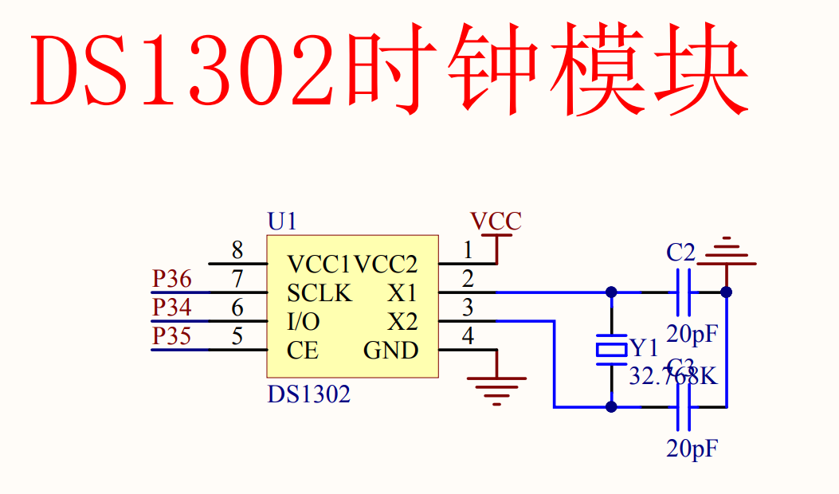

**Pins Description:**

**1. VCC1 (Pin 8)**

* **Abbreviation**: **VCC** stands for **Voltage Common Collector**.
* **Function**: This is the main power supply pin for the DS1302. It’s where you connect the primary power source (usually 5V or 3.3V).

**2. VCC2 (Pin 1)**

* **Abbreviation**: **VCC** (same as VCC1).
* **Function**: This pin is connected to a backup battery. When the main power (VCC1) is off, the DS1302 uses the backup battery connected to VCC2 to keep the time running.

**3. SCLK (Pin 7)**

* **Abbreviation**: **SCLK** stands for **Serial Clock**.
* **Function**: This pin is used to provide a clock signal to synchronize data transfer between the DS1302 and the microcontroller. It helps to tell the chip when to read or write data.

**4. I/O (Pin 6)**

* **Abbreviation**: **I/O** stands for **Input/Output**.
* **Function**: This is the data pin, used for both sending (writing) and receiving (reading) data. It acts as a bidirectional pin for communication.

**5. CE (Pin 5)**

* **Abbreviation**: **CE** stands for **Chip Enable**.
* **Function**: This pin is used to activate the DS1302 for communication. When this pin is high (connected to a voltage source), the DS1302 is ready to communicate. If it's low, the DS1302 ignores all inputs.

**6. X1 (Pin 2)**

* **Abbreviation**: **X1** refers to the first terminal of the **Crystal Oscillator**.
* **Function**: This pin connects to one side of the crystal oscillator (Y1). The crystal oscillator helps keep the time accurate.

**7. X2 (Pin 3)**

* **Abbreviation**: **X2** refers to the second terminal of the **Crystal Oscillator**.
* **Function**: This pin connects to the other side of the crystal oscillator. Together with X1, it completes the connection to the external crystal, which oscillates at a specific frequency (32.768 kHz in this case).

**8. GND (Pin 4)**

* **Abbreviation**: **GND** stands for **Ground**.
* **Function**: This is the ground pin that completes the electrical circuit. It is connected to the ground of the power supply.

**Additional Components in the Schematic:**

* **Y1 (32.768K)**: This is the crystal oscillator connected between pins X1 and X2. It oscillates at a frequency of 32.768 kHz, which is a standard frequency for real-time clocks.
* **C1 and C2 (20pF)**: These are capacitors connected to the crystal oscillator. They help stabilize the oscillation of the crystal.

This setup allows the DS1302 to accurately keep track of time, with the crystal oscillator providing the necessary precision for counting seconds, minutes, and so on. The microcontroller communicates with the DS1302 through the SCLK, I/O, and CE pins, while VCC1, VCC2, and GND provide the necessary power.

**A very simple and detail note about RTC:**

**1. What is the DS1302 RTC?**

The DS1302 is a tiny chip that acts like a clock for electronic devices. Just like the clock on your wall or your wristwatch, it keeps track of time—seconds, minutes, hours, and even the date, including day, month, and year. It also remembers the time even when the power goes off, thanks to a little backup battery.

**2. How Does the DS1302 Work?**

The DS1302 has a small memory inside it that stores the time and date. It counts time based on an external crystal oscillator (a tiny component that ticks very precisely) connected to it. This ticking helps the DS1302 know exactly when one second has passed, then one minute, and so on.

**3. Pins of the DS1302**

The DS1302 has 8 small metal legs, which we call pins. Each pin has a specific job:

* **VCC**: This pin is where the chip gets power, like the battery in a clock.
* **GND**: This is the ground pin, which completes the electrical circuit.
* **CLK**: The clock pin that tells the DS1302 when to listen for commands.
* **DAT**: The data pin is like the mouth and ears of the chip—it’s used to send and receive information.
* **RST**: The reset pin wakes up the DS1302 to start communicating with it.
* **X1 and X2**: These two pins connect to the crystal oscillator, which keeps the time ticking.
* **VCC2**: This pin is for the backup battery, so the clock keeps running when the main power is off.

**4. How to Talk to the DS1302**

The DS1302 communicates with other devices (like a microcontroller) through a special language called serial communication. This means it sends or receives data one bit at a time through the DAT pin, kind of like sending a letter one letter at a time instead of a whole word.

* **Clock Signal (CLK)**: This is like the rhythm or beat that helps the DS1302 and the microcontroller stay in sync when talking.
* **Command Byte**: When you want the DS1302 to do something (like set the time), you send a command byte first. This is like giving an instruction, such as “Set the time to 10:00 AM.”
* **Read/Write**: The chip can either write (store) new data or read (give back) data. You tell it what to do by setting the read/write bit in the command.

**5. What Can You Do with the DS1302?**

* **Set the Time and Date**: You can tell the DS1302 what the current time and date are, and it will keep track of them.
* **Read the Time and Date**: You can ask the DS1302 what time it is, and it will tell you the exact time and date.
* **Trickle Charge**: The DS1302 has a feature that allows it to slowly charge the backup battery. This helps the battery last longer.

**6. Important Registers**

Registers are like small boxes inside the DS1302 where it stores different pieces of information. Some important registers include:

* **Seconds, Minutes, Hours**: These registers store the current time.
* **Day, Date, Month, Year**: These registers store the current date.
* **Control Register**: This register controls special functions, like whether to use a 24-hour or 12-hour clock.

**7. Power Management**

The DS1302 is designed to use very little power, which is important for a device that needs to keep working even when the main power is off. The backup battery connected to the VCC2 pin powers it when the main power is unavailable.

**8. Applications of DS1302**

* **Clocks and Watches**: The DS1302 can be used in digital clocks and watches.
* **Alarms**: It can be used in devices that need to trigger an event at a specific time.
* **Data Logging**: The DS1302 can help keep track of when certain data was recorded in devices like weather stations or smart meters.

**9. Summary**

The DS1302 is a small, powerful clock chip that can keep track of time and date, even when the power is off, thanks to its backup battery. It uses serial communication to talk to other devices, and it’s very power-efficient, making it useful in many different kinds of electronic projects.

**How Does the DS1302 Works?**

**1. What is DS1302 RTC:**

Imagine the DS1302 as a little timekeeper inside an electronic device. Its job is to keep track of the current time (like hours, minutes, and seconds) and the date (like day, month, and year). It’s like having a tiny clock that remembers the time even when the power goes off.

**2. How It Keeps Time**

The DS1302 keeps track of time using a small, precise "ticking" part called a crystal oscillator. This crystal ticks at a steady pace, just like the second hand on a clock. Every time the crystal ticks, the DS1302 knows that one second has passed, then another, and so on. It counts these ticks to keep track of time.

**3. Powering the DS1302**

The DS1302 needs electricity to work, just like any clock needs a battery. There are two power sources:

* **Main Power (VCC1)**: This is like the main battery of the device. When the device is on, the DS1302 gets power from here.
* **Backup Battery (VCC2)**: This is like a spare battery. If the main power goes off (for example, if the device is turned off or unplugged), the DS1302 switches to this backup battery. This way, it can keep track of time even when the main power is off.

**4. Communicating with the DS1302**

To set the time or read the time from the DS1302, you need to "talk" to it using a microcontroller (like an Arduino, Raspberry Pi, or another type of computer chip). This communication happens through three special pins:

* **SCLK (Serial Clock)**: Think of this as the beat or rhythm that keeps both the DS1302 and the microcontroller in sync when they’re talking to each other.
* **I/O (Input/Output)**: This is like a two-way street. Data can flow in both directions—either the microcontroller sends information to the DS1302 (like setting the time), or the DS1302 sends information back (like telling the microcontroller what time it is).
* **CE (Chip Enable)**: This pin is like a switch. When you turn it on, the DS1302 is ready to listen or talk. When it’s off, the DS1302 ignores everything, saving power.

**5. Setting the Time and Date**

When you want to set the time and date on the DS1302, you send a special command to it through the I/O pin. For example, if you want to set the time to 3:45 PM on August 12, 2024, you would send this information bit by bit to the DS1302, and it would store this data in its internal memory.

**6. Reading the Time and Date**

When you want to know the current time and date, you ask the DS1302 through the I/O pin. The DS1302 then sends the stored time and date back to the microcontroller, which can display it on a screen or use it in some other way.

**7. Trickle Charger**

The DS1302 also has a neat feature called a "trickle charger." This slowly charges the backup battery when the main power is on, making sure the backup battery lasts a long time. It’s like slowly refilling a backup tank of water while using the main tank.

**8. Always Accurate**

Thanks to the crystal oscillator, the DS1302 keeps time very accurately. It’s designed to use very little power, which is why it can run on a tiny backup battery for a long time without losing track of the time.

**Summary**

* The DS1302 is a little clock chip that keeps track of time and date.
* It uses a crystal oscillator to tick away the seconds.
* It can switch to a backup battery if the main power goes off, so it never forgets the time.
* You can set or read the time by "talking" to the DS1302 through a microcontroller.

This is a simple explanation, but the DS1302 is a clever little device that helps many electronic gadgets keep accurate time.

|  |
| --- |
|  |

|  |
| --- |
|  |

**Communicating with the DS1302 RTC using an MCU(89C52RC):**

Communicating with the DS1302 RTC using an MCU like the 89C52RC (which is a type of 8051 microcontroller) involves connecting the right pins and sending the right commands to set or read the time and date. Here's how you can do it:

**1. Connecting the DS1302 to the 89C52RC**

First, you'll need to connect the DS1302 to the 89C52RC microcontroller. Here's a simple connection scheme:

* **VCC1 and VCC2**: Connect these to your power supply (typically 5V).
* **GND**: Connect this to the ground (GND) of your power supply.
* **SCLK (Serial Clock, Pin 7)**: Connect this to any available GPIO pin on the 89C52RC. For example, connect it to P3.0 (Pin 10 on 89C52RC).
* **I/O (Input/Output, Pin 6)**: Connect this to another GPIO pin on the 89C52RC, such as P3.1 (Pin 11 on 89C52RC).
* **CE (Chip Enable, Pin 5)**: Connect this to another GPIO pin on the 89C52RC, such as P3.2 (Pin 12 on 89C52RC).
* **X1 and X2**: Connect a 32.768 kHz crystal oscillator between these pins, with capacitors to ground (as shown in your earlier schematic).

**2. Writing the Code to Communicate with DS1302**

To talk to the DS1302, you'll need to write code that handles the following:

* **Initializing Communication**: You need to set up the 89C52RC's GPIO pins correctly and prepare them for communication.
* **Sending Commands**: You'll send specific commands to set or read the time and date.
* **Reading/Writing Data**: You'll send or receive the actual time and date information.

Here’s a simple example of how you might write this code in C:

**2.1. Define the GPIO Pins**

**Code**

sbit SCLK = P3^0; // Connect SCLK to P3.0

sbit IO = P3^1; // Connect I/O to P3.1

sbit CE = P3^2; // Connect CE to P3.2

**2.2. Functions for Communication**

Now, let’s write functions to send and receive data:

* **Function to Send a Byte to DS1302**:

**Code**

void DS1302_WriteByte(unsigned char byte) {

unsigned char i;

for (i = 0; i < 8; i++) {

IO = byte & 0x01; // Send the least significant bit first

SCLK = 1; // Pulse the clock

byte >>= 1; // Shift the byte right

SCLK = 0; // Reset the clock

}

}

* **Function to Read a Byte from DS1302**:

**Code**

unsigned char DS1302_ReadByte() {

unsigned char i, byte = 0;

for (i = 0; i < 8; i++) {

byte >>= 1; // Shift the byte right

if (IO) {

byte |= 0x80; // If IO is high, set the MSB

}

SCLK = 1; // Pulse the clock

SCLK = 0; // Reset the clock

}

return byte;

}

* **Function to Start Communication**:

**code**

void DS1302_Start() {

CE = 1; // Enable the DS1302

SCLK = 0;

}

* **Function to Stop Communication**:

c

Copy code

void DS1302_Stop() {

CE = 0; // Disable the DS1302

}

**2.3. Setting the Time**

To set the time, you would send the appropriate command to write data to the DS1302. For example, to set the seconds:

**code**

void DS1302_SetTime(unsigned char hour, unsigned char minute, unsigned char second) {

DS1302_Start();

DS1302_WriteByte(0x80); // Command to write to the seconds register

DS1302_WriteByte(second); // Write the seconds

DS1302_Stop();

DS1302_Start();

DS1302_WriteByte(0x82); // Command to write to the minutes register

DS1302_WriteByte(minute); // Write the minutes

DS1302_Stop();

DS1302_Start();

DS1302_WriteByte(0x84); // Command to write to the hours register

DS1302_WriteByte(hour); // Write the hours

DS1302_Stop();

}

**2.4. Reading the Time**

To read the time, you would send the command to read data from the DS1302, like this:

**code**

unsigned char DS1302_GetSeconds() {

unsigned char seconds;

DS1302_Start();

DS1302_WriteByte(0x81); // Command to read the seconds register

seconds = DS1302_ReadByte();

DS1302_Stop();

return seconds;

}

unsigned char DS1302_GetMinutes() {

unsigned char minutes;

DS1302_Start();

DS1302_WriteByte(0x83); // Command to read the minutes register

minutes = DS1302_ReadByte();

DS1302_Stop();

return minutes;

}

unsigned char DS1302_GetHours() {

unsigned char hours;

DS1302_Start();

DS1302_WriteByte(0x85); // Command to read the hours register

hours = DS1302_ReadByte();

DS1302_Stop();

return hours;

}

**3. Putting It All Together**

Once you have the basic functions, you can write a main function to set or get the time:

**code**

void main() {

unsigned char hours, minutes, seconds;

// Example: Set time to 10:30:00

DS1302_SetTime(10, 30, 0);

// Example: Get the current time

seconds = DS1302_GetSeconds();

minutes = DS1302_GetMinutes();

hours = DS1302_GetHours();

while (1) {

// Continuously do something with the time, like displaying it

}

}

**4. Summary**

* **Connect the DS1302 to the 89C52RC**: Use the GPIO pins for SCLK, I/O, and CE.
* **Write Code to Communicate**: Implement functions to start and stop communication, write to, and read from the DS1302.
* **Set or Get Time**: Use the functions to set the time and read the current time.

By following these steps, you can effectively communicate with the DS1302 using your 89C52RC microcontroller, allowing you to set and retrieve time and date information in your projects.

**What Can You Do with the DS1302?**

**1. Keep Track of Time**

* **Basic Clock Functions**: The DS1302 keeps track of the current time, including hours, minutes, and seconds. You can use it in projects that need to display the current time, like digital clocks or watches.
* **Alarm Systems**: By checking the current time against a preset alarm time, you can create alarm clocks or timers that perform specific actions at a certain time.

**2. Store and Retrieve Date Information**

* **Calendar Applications**: The DS1302 can also store and keep track of the date, including day, month, and year. This is useful for calendar-based applications where you need to know the current date.
* **Reminders and Schedules**: You can create systems that trigger events based on the date, such as reminders or scheduled tasks.

**3. Power-Independent Timekeeping**

* **Battery Backup**: The DS1302 has the ability to switch to a backup battery when the main power is lost. This means it can keep accurate time even when the device it’s in is powered off. This is useful in devices like computers or home automation systems where accurate timekeeping is crucial even during power outages.

**4. Data Logging**

* **Time-Stamped Data**: In projects where you collect data over time, such as temperature monitoring or event logging, the DS1302 can provide accurate time stamps for each data point. This allows you to keep a precise record of when each piece of data was recorded.

**5. Automation and Control**

* **Time-Based Automation**: The DS1302 can be used in systems that need to perform actions at specific times. For example, you could create a system that turns lights on and off at certain times of the day or controls other appliances based on time schedules.
* **Home Automation**: Integrating the DS1302 with a home automation system can enable you to automate daily tasks, like controlling heating, lighting, or irrigation based on the time of day.

**6. Simple Timekeeping Projects**

* **Educational Projects**: The DS1302 is great for learning about real-time clocks and timekeeping in electronics. Students and hobbyists can use it to understand how electronic devices keep track of time and how to interface with them using microcontrollers.
* **Digital Clocks and Watches**: You can create your own digital clocks or wristwatches using the DS1302, which can display time and date and potentially include features like alarms.

**7. Embedded Systems**

* **Microcontroller Projects**: In any microcontroller-based project that requires accurate timekeeping, the DS1302 can be integrated. Whether it’s a simple Arduino project or a more complex embedded system, the DS1302 can provide the necessary time and date functionality.
* **Time-Sensitive Applications**: For systems where actions need to be triggered at specific times or intervals, such as timed data collection or periodic tasks, the DS1302 is an ideal solution.

**8. Low-Power Timekeeping**

* **Energy-Efficient Systems**: The DS1302 is designed to use very little power, making it perfect for low-power or battery-operated devices. Even in devices that need to run for years on a small battery, the DS1302 can provide reliable timekeeping.

**Summary**

The DS1302 can be used in a wide range of applications, from simple clocks to complex automation systems. It’s a small but powerful chip that enables accurate and reliable timekeeping, which is essential for many electronics projects. Whether you’re building a digital clock, automating your home, or creating a data logger, the DS1302 can be a crucial component.

**Important Registers in RTC:**

In the DS1302 Real-Time Clock (RTC), several important registers are used to store time, date, control, and status information. Understanding these registers is crucial for interacting with the DS1302 effectively. Here’s an overview of the key registers:

**1. Timekeeping Registers**

These registers store the current time, including seconds, minutes, and hours.

* **Seconds Register (0x80, 0x81)**:
  + Stores the current seconds value (00 to 59).
  + The clock halt bit (CH) is located in this register; when CH is set to 1, the oscillator is stopped, and the clock is halted.
* **Minutes Register (0x82, 0x83)**:
  + Stores the current minutes value (00 to 59).
* **Hours Register (0x84, 0x85)**:
  + Stores the current hour value.
  + Can be in either 24-hour format (00 to 23) or 12-hour format (01 to 12 with an AM/PM indicator).

**2. Calendar Registers**

These registers keep track of the date, including the day, date, month, and year.

* **Day Register (0x86, 0x87)**:
  + Stores the day of the week (01 to 07, where 01 typically represents Sunday).
* **Date Register (0x88, 0x89)**:
  + Stores the day of the month (01 to 31).
* **Month Register (0x8A, 0x8B)**:
  + Stores the current month (01 to 12).
* **Year Register (0x8C, 0x8D)**:
  + Stores the last two digits of the year (00 to 99).

**3. Control Register (0x8E)**

This register controls the operating mode of the DS1302.

* **Write Protect (WP) Bit**:
  + Located in the control register, this bit protects the clock and calendar registers from being written to.
  + If WP is set to 1, no data can be written to the time and calendar registers.
  + If WP is set to 0, the registers can be written to.

**4. Trickling Charge Register (0x90)**

This register is used for controlling the trickle charger, which can charge an external battery or capacitor.

* **Trickle Charger Enable (TCE) Bit**:
  + Enables or disables the trickle charger.
  + When the TCE bit is set, the DS1302 charges an external backup power source (like a supercapacitor).
* **Diodes and Resistors Bits**:
  + These bits select the number of diodes and resistors in the trickle charge circuit, which controls the charging current.

**5. Clock Burst Mode**

* **Burst Mode Address (0xBE for read, 0xBF for write)**:
  + In burst mode, you can read or write multiple registers in a single operation, starting from the seconds register and continuing through the year register.
  + This is useful for quickly updating or reading the entire clock and calendar information.

**6. RAM Registers (0xC0 to 0xFF)**

* **User RAM**:
  + The DS1302 includes 31 bytes of static RAM that can be used to store user data.
  + These registers are non-volatile, meaning they retain their data even when the power is lost, as long as a backup battery is connected.

**7. Clock Halt (CH) Bit**

* **Located in the Seconds Register (Bit 7)**:
  + This bit stops the clock when set to 1.
  + It is essential to clear this bit (set it to 0) when starting the DS1302 to ensure the clock runs properly.

**Summary**

The DS1302 RTC contains several important registers that manage time, date, control, and additional functions like the trickle charger and user RAM. These registers are accessed using specific commands, and understanding their purpose and structure is crucial for effective communication with the DS1302. By configuring these registers correctly, you can maintain accurate timekeeping, manage date information, and utilize additional features like the trickle charger.

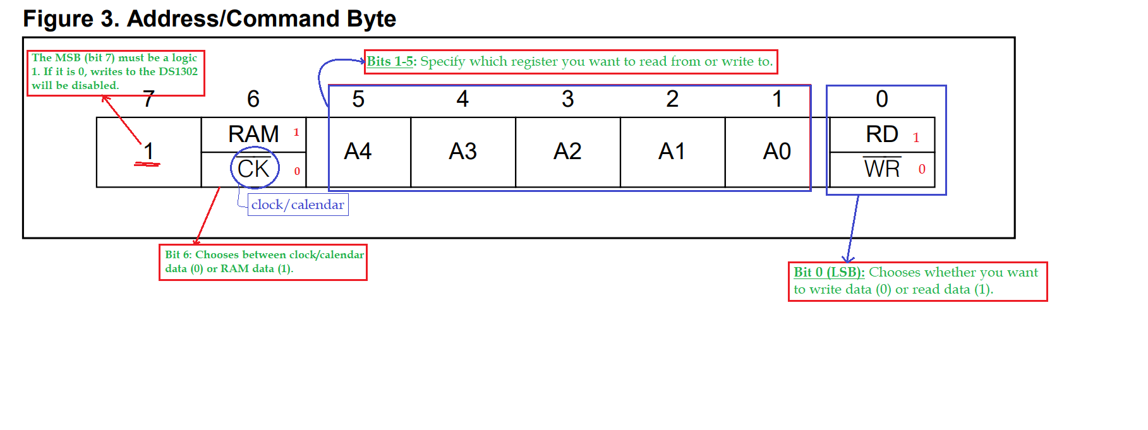

**Data Input (Writing Data to DS1302)**

* **Write Command**: First, you send a special command (called a "write command byte") to the DS1302, which tells it you're about to send data.
* **Sending Data**: After that command, the data you want to send gets transmitted bit by bit. This happens over 8 tiny time steps (called "SCLK cycles").
* **Starting Point**: The first bit you send is the smallest bit (Bit 0).
* **Extra Time Steps**: If you accidentally keep the clock running after sending the data, the DS1302 will ignore these extra steps.

**Data Output (Reading Data from DS1302)**

* **Read Command**: First, you send a different command (called a "read command byte") that tells the DS1302 you're about to receive data from it.
* **Receiving Data**: The DS1302 then sends you the data bit by bit over 8 time steps (SCLK cycles).
* **Starting Point**: The first bit you receive is the smallest bit (Bit 0), and this bit comes right after the last bit of your read command.
* **Extra Time Steps**: If the clock keeps running after you receive the data, the DS1302 will keep sending you the same data again and again until you stop it.
* **Tristate**: The DS1302's I/O pin temporarily disconnects after each time step, making sure it doesn’t interfere with any other signals.

So, in simpler terms: when writing to the DS1302, you send a command followed by data bit by bit. When reading from it, you send a command, and it sends the data bit by bit back to you. If you keep sending or receiving when you shouldn't, the DS1302 knows to ignore or repeat data as needed.

### What is Burst Mode?

**Burst Mode** is a special way of quickly reading from or writing to multiple registers (sections of memory) in the DS1302, either in the clock/calendar section or the RAM (random access memory) section.

### Breaking It Down:

1. **Addressing Burst Mode**:
   * To use burst mode, you send a command that specifically targets the address **31** in decimal.
   * **Bit 6** tells the DS1302 whether you’re working with the clock/calendar or RAM.
   * **Bit 0** tells the DS1302 whether you want to read data (1) or write data (0).
2. **No Extra Data Storage**:
   * In the clock/calendar section, there’s no actual data storage between locations 9 to 31, meaning these locations don’t hold any useful information. So, when you work in burst mode, you’re dealing with the first 8 locations (addresses 0 to 8).
   * In RAM, location 31 doesn’t have any data storage either.
3. **How Burst Mode Works**:
   * **Writing to Clock/Calendar in Burst Mode**: When you write data in burst mode to the clock/calendar section, you must write to all 8 of the first registers (addresses 0 to 7). If you miss even one, none of the data will be saved.
   * **Writing to RAM in Burst Mode**: For RAM, you don’t need to write to all 31 locations. If you only write to a few, those specific ones will be saved, and the rest can be left alone.

### Example to Make It Simple:

#### Writing to the Clock/Calendar in Burst Mode:

* Imagine you have a book with 8 pages (representing the 8 registers in the clock/calendar).
* You need to write on all 8 pages at once. If you leave even one page blank, the entire book will be considered incomplete, and none of your writing will count.

#### Writing to RAM in Burst Mode:

* Now, imagine another book with 31 pages (representing the 31 RAM registers).
* In this case, you can choose to write on only a few pages, and those pages will be saved. It doesn’t matter if you leave some pages blank—the pages you wrote on will still be remembered.

### Summary:

* **Burst Mode** allows you to read or write multiple registers quickly.
* For the **clock/calendar**, you must write to all 8 registers for the data to be saved.
* For **RAM**, you can write to any number of the 31 registers, and only the ones you write to will be saved.

**1. Time and Calendar Data:**

* The DS1302 stores time (hours, minutes, seconds) and calendar information (day, month, year) in special memory locations called registers.
* These registers store the time and date in a format called **BCD (Binary-Coded Decimal)**. BCD is a way to store each digit of a number separately, making it easier to display or manipulate the data.

**2. Day of the Week:**

* The DS1302 keeps track of the day of the week (Sunday, Monday, etc.) using a special register.
* You can assign numbers to days (e.g., 1 for Sunday, 2 for Monday, etc.), but they must follow a logical sequence. If you assign 1 to Sunday, 2 must be Monday, 3 must be Tuesday, and so on.
* This register updates itself at midnight, moving to the next day automatically.

**3. Safe Reading and Writing:**

* When you read or write time and date information, the DS1302 uses secondary (backup) buffers to prevent errors. These buffers ensure that you get accurate data even if the internal clock is updating at the same time.
* The backup buffers sync with the main registers when a signal (CE) goes from low to high.

**4. Resetting the Countdown Chain:**

* The "countdown chain" is a mechanism inside the DS1302 that keeps track of the time.
* If you write new data to the seconds register, the countdown chain resets. After that, you must update the other time and date registers (minutes, hours, etc.) within 1 second to avoid timing issues.

**5. 12-Hour or 24-Hour Mode:**

* The DS1302 can operate in either 12-hour mode (with AM/PM) or 24-hour mode.
* A special bit (bit 7) in the hours register decides which mode is active. If bit 7 is set to 1, the DS1302 uses 12-hour mode. If it's 0, it uses 24-hour mode.
* In 12-hour mode, another bit (bit 5) indicates AM (morning) or PM (afternoon/evening). In 24-hour mode, bit 5 helps represent hours from 20 to 23.
* If you switch between 12-hour and 24-hour modes, you must reinitialize (reset) the hours data to avoid incorrect time display.

**Summary:**

This explanation covers how the DS1302 manages and protects time and date data, handles day-of-the-week updates, ensures safe data reads/writes, and switches between 12-hour and 24-hour time formats.

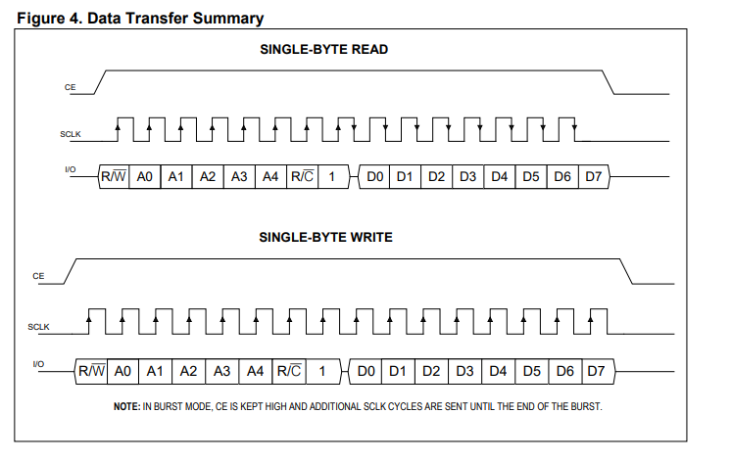

**What We're Looking At:**

This picture is like a set of instructions that show how information is sent and received between two devices, like a conversation between two people where one person speaks, and the other listens.

**Key Parts:**

1. **CE (Chip Enable):** This is like a signal that tells the DS1302 (the little clock chip) when to start listening or talking. It’s like someone raising their hand to say, "I'm ready to speak!".
2. **SCLK (Serial Clock):** This is like a ticking clock that keeps the conversation in rhythm, making sure everything is said and heard at the right time.
3. **I/O (Input/Output):** This is where the actual information (data) is sent or received. It's like the voice in our conversation.

**Two Types of Conversations:**

1. **Single-Byte Read (Top Part):**
   * Imagine you're asking the chip a question, like "What time is it?"
   * **R/W** (Read/Write) starts the conversation by saying, "I want to read (ask a question)."
   * The next few parts (A0, A1, A2, etc.) are like addresses on a street, telling the chip exactly what information you want.
   * **R/C** is just an extra check to make sure everything is in order.
   * The chip then answers with the data (D0, D1, D2, etc.), which might be the time, date, or something else.
2. **Single-Byte Write (Bottom Part):**
   * Here, you’re telling the chip something, like setting the clock to a specific time.
   * **R/W** says, "I want to write (tell you something)."
   * The addresses (A0, A1, A2, etc.) tell the chip where to store the information you're sending.
   * The data (D0, D1, D2, etc.) is the actual information, like the time you want to set.

**Extra Note:**

* In **Burst Mode** (like a rapid conversation), the chip keeps listening until everything is said, so it stays alert for a longer time (CE stays high).

**Summary:**

This diagram is showing us how a tiny computer chip listens or talks when you ask it for information or tell it something, just like how two people would have a conversation. The top part shows how to ask it a question, and the bottom part shows how to tell it something.

### Overview of Data Transfer

The diagram shows the communication protocol between a microcontroller and the DS1302 RTC (Real-Time Clock) chip. The communication follows a serial protocol, where data is transferred one bit at a time along a single data line. This method uses three key signals:

* **CE (Chip Enable)**: Activates the DS1302 for communication.
* **SCLK (Serial Clock)**: Synchronizes the data transfer by providing a clock pulse.
* **I/O (Input/Output)**: The data line where information is read from or written to the DS1302.

### Single-Byte Read

#### Sequence Breakdown:

1. **CE Activation**: The CE line is driven high, signaling to the DS1302 that a communication session is starting. The chip is now ready to either send or receive data depending on the R/W bit.
2. **R/W Bit**: This bit is set to '1' to indicate a read operation. The microcontroller tells the DS1302 that it intends to read data from one of its registers.
3. **Address Bits (A0 to A4)**: The next five bits specify the register address within the DS1302 from which the data will be read. These address bits are crucial as they point to the specific memory location, such as seconds, minutes, or control registers.
4. **R/C Bit**: The R/C bit is typically a '1' during a read operation, ensuring the operation is interpreted correctly by the DS1302.
5. **Data Transfer (D0 to D7)**: After the address is sent, the DS1302 sends back 8 bits of data, representing the value stored in the specified register. The microcontroller reads this data on each clock pulse generated by the SCLK.
6. **CE Deactivation**: Once the data is received, CE is driven low, ending the communication session.

### Single-Byte Write

#### Sequence Breakdown:

1. **CE Activation**: Similar to a read operation, CE is driven high to initiate communication with the DS1302.
2. **R/W Bit**: For a write operation, the R/W bit is set to '0', indicating that the microcontroller will send data to be stored in one of the DS1302's registers.
3. **Address Bits (A0 to A4)**: The next five bits specify the target register within the DS1302 where the data will be written.
4. **R/C Bit**: For write operations, this bit is typically '0', ensuring that the DS1302 is ready to receive data.
5. **Data Transfer (D0 to D7)**: The microcontroller sends 8 bits of data, representing the value to be written into the specified register. This data could be anything from setting the time to configuring the control register.
6. **CE Deactivation**: After sending the data, the microcontroller drives CE low, concluding the communication.

### Important Notes:

* **Burst Mode**: The diagram includes a note about burst mode, where CE is held high, allowing multiple bytes of data to be transferred sequentially. This is used when reading or writing multiple registers in one continuous operation, reducing the overhead of restarting communication for each byte.
* **Synchronization and Data Integrity**: The SCLK signal ensures that data is synchronized between the microcontroller and the DS1302. Each bit of data is transferred on the rising edge of the clock, ensuring data integrity during high-speed transfers.

### Application Context:

This communication protocol is integral to the operation of the DS1302 RTC. Engineers use this protocol to interact with the RTC for tasks such as setting the time, reading the current time, or configuring various control settings within the RTC. Understanding this protocol is essential for ensuring reliable and accurate timekeeping in embedded systems where the DS1302 is used.

In summary, this data transfer summary outlines the structured and synchronized communication between a microcontroller and the DS1302 RTC, detailing both the sequence of operations and the specific bits involved in reading from and writing to the RTC's internal registers. This understanding is crucial for developing firmware that correctly interfaces with the DS1302.

**Asynchronous and synchronous data communication:**

Asynchronous and synchronous data communication are two fundamental methods of transmitting data between devices. They differ in how they handle timing, synchronization, and data transfer. Here's a detailed comparison:

**1. Timing and Synchronization**

* **Asynchronous Communication:**
  + In asynchronous communication, data is sent one byte or character at a time, with each byte being individually synchronized using start and stop bits.
  + There is no need for the sender and receiver to share a common clock signal.
  + The timing between bytes can vary, as each byte is sent independently, allowing for gaps in the transmission.
  + Example: Serial communication using RS-232 (e.g., UART communication).
* **Synchronous Communication:**
  + In synchronous communication, data is sent as a continuous stream, and both the sender and receiver share a common clock signal.
  + The clock signal ensures that the sender and receiver are synchronized, allowing for a steady and continuous flow of data without the need for start and stop bits.
  + The timing is consistent, with no gaps between the transmitted data, making it more efficient for high-speed data transfer.
  + Example: SPI (Serial Peripheral Interface), I2C (Inter-Integrated Circuit).

**2. Start and Stop Bits**

* **Asynchronous Communication:**
  + Requires start and stop bits to frame each byte of data.
  + A start bit indicates the beginning of a byte, and a stop bit indicates the end, helping the receiver identify the boundaries of each byte.
  + These extra bits add overhead to the communication.
* **Synchronous Communication:**
  + Does not require start and stop bits, as the timing is managed by the shared clock signal.
  + The absence of these bits reduces overhead, allowing for more efficient use of the communication channel.

**3. Data Transfer Rate**

* **Asynchronous Communication:**
  + Typically slower due to the additional overhead of start and stop bits.
  + Suitable for low to moderate-speed data transmission where data may be sent intermittently or with varying timing.
* **Synchronous Communication:**
  + Generally faster because of the continuous data stream and absence of start and stop bits.
  + Ideal for high-speed data transfer where large amounts of data are transmitted in a continuous flow.

**4. Complexity**

* **Asynchronous Communication:**
  + Simpler to implement, as it doesn't require a shared clock signal.
  + Easier to manage in systems where timing may be variable or where devices operate at different speeds.
* **Synchronous Communication:**
  + More complex to implement, requiring precise clock synchronization between the sender and receiver.
  + More suited for systems where high-speed, consistent data transfer is needed, and both devices can maintain synchronization.

**5. Use Cases**

* **Asynchronous Communication:**
  + Used in scenarios where data is sent sporadically or where the devices do not share a common clock.
  + Examples include standard serial ports (e.g., UART communication), communication between a computer and a peripheral device like a mouse or keyboard.
* **Synchronous Communication:**
  + Used in applications requiring high-speed data transfer with minimal overhead.
  + Examples include communication between microcontrollers and sensors, memory chips, or other high-speed peripherals using protocols like SPI, I2C, or Ethernet.

**Summary**

* **Asynchronous Communication** is more flexible and easier to implement but comes with added overhead and slower speeds due to start and stop bits.
* **Synchronous Communication** is more efficient and faster but requires more complex synchronization between devices.

These differences make asynchronous communication well-suited for simpler, lower-speed applications, while synchronous communication is preferred for high-speed, time-sensitive data transfer.

**The communication between the RTC DS1302 and the 8051 microcontroller is synchronous.**

### Here's why:

* **Synchronous Communication:**
  + The DS1302 RTC communicates with the 8051 microcontroller using a synchronous serial interface, which involves three lines: **CLK (Clock)**, **I/O (Data)**, and **CE (Chip Enable)**.
  + The **CLK** line provides the clock signal that synchronizes the data transfer between the DS1302 and the microcontroller.
  + The **I/O** line is used for bidirectional data transfer, meaning it can both send and receive data based on the clock signal.
  + The **CE** line is used to enable or disable the communication with the DS1302. When the CE line is active, the DS1302 is ready to communicate with the microcontroller.

### Key Characteristics:

* **Clock Signal (CLK):** The clock signal is essential for synchronization, ensuring that the DS1302 and 8051 microcontroller are in sync during data transfer.
* **No Start/Stop Bits:** Unlike asynchronous communication, where start and stop bits frame each byte of data, synchronous communication in the DS1302 does not require these bits. The clock signal itself ensures that both devices remain synchronized.
* **Continuous Data Transfer:** Data is transferred in sync with the clock signal, allowing for efficient communication without the additional overhead of start and stop bits.

### Conclusion:

Since the DS1302 RTC relies on a clock signal to synchronize data transfer with the 8051 microcontroller, the communication between them is **synchronous**.

What do u think is burst mode in rtc and single byte transfering/data or command is what type of data communication ?

In the context of RTCs (Real-Time Clocks) like the DS1302, **burst mode** and **single-byte transferring** are both types of data communication methods. Here's how each one works and how they fit into the communication types:

### Burst Mode

**Burst Mode** is a type of **synchronous** communication where multiple bytes of data are transferred in a continuous sequence without the need for repeated command initiation between each byte.

* **How It Works:**
  + You initiate burst mode with a single command, and then you can send or receive a stream of data bytes in one continuous operation.
  + This is efficient because it reduces the number of command bytes and handshaking required compared to individual byte transfers.
* **Communication Type:**
  + **Synchronous:** Because burst mode requires a clock signal to synchronize the data transfer between the RTC and the microcontroller. The data is transmitted or received in sync with the clock signal.

### Single-Byte Transferring

**Single-Byte Transferring** involves sending or receiving one byte of data at a time, which can be done in two modes:

* **Single-Byte Write:**
  + A command is sent to write a single byte of data to a specific register in the RTC.
* **Single-Byte Read:**
  + A command is sent to read a single byte of data from a specific register in the RTC.
* **Communication Type:**
  + **Synchronous:** Similar to burst mode, single-byte transfers in the DS1302 also use a clock signal to synchronize data transfer. Even though each byte is transferred separately, the clock signal ensures that data is correctly timed and synchronized.

### Summary

* **Burst Mode:** A form of **synchronous communication** where multiple bytes are transferred in a single continuous sequence, efficient for transferring larger blocks of data.
* **Single-Byte Transfer:** Also **synchronous**, but involves transferring data one byte at a time, which might be used for operations requiring only a small amount of data or specific register access.

Both methods use the clock signal for synchronization, categorizing them as synchronous communication. Burst mode is just a more efficient way to handle multiple data bytes in a single operation compared to handling each byte individually.

**When to set our I/O pin in RTC module to input and output?**

In an RTC module like the DS1302, setting the I/O pin to input or output is crucial for proper communication. Here’s how and when to set the I/O pin for each mode:

**1. Setting the I/O Pin to Output:**

* **When to Set to Output:**
  + **Writing Data:** When you need to send data or commands from the microcontroller to the RTC, the I/O pin should be set to output mode. This allows the microcontroller to drive the I/O line and send the data to the RTC.
  + **Sending Commands:** For operations such as writing to the RTC’s registers (setting time, date, etc.), you need to set the I/O pin to output mode to transmit the appropriate command bytes and data.
* **How to Set to Output:**
  + Configure the I/O pin of the microcontroller (connected to the DS1302’s I/O pin) as an output in your microcontroller's code or configuration settings.
  + Ensure the I/O pin is correctly driven high or low according to the data being sent.

**2. Setting the I/O Pin to Input:**

* **When to Set to Input:**
  + **Reading Data:** When you need to read data or status from the RTC, the I/O pin should be set to input mode. This allows the microcontroller to read the data that the RTC sends out on the I/O line.
  + **Receiving Responses:** For operations such as reading the time or date from the RTC, or checking the status of certain registers, you set the I/O pin to input mode to capture the data provided by the RTC.
* **How to Set to Input:**
  + Configure the I/O pin of the microcontroller (connected to the DS1302’s I/O pin) as an input in your microcontroller's code or configuration settings.
  + Ensure that the microcontroller correctly reads the data from the I/O pin when it is set to input mode.

**Practical Example in DS1302 Communication:**

1. **Initiate Communication:**
   * Set the **CE (Chip Enable)** pin high to enable communication with the DS1302.
2. **Write Data:**
   * Set the **I/O (Data)** pin to output mode.
   * Send the command byte (e.g., for burst write mode) and then the data bytes you want to write.
3. **Read Data:**
   * Set the **I/O (Data)** pin to input mode.
   * Send the command byte to initiate the read operation, and then read the data bytes that the DS1302 sends back.
4. **Terminate Communication:**
   * Set the **CE (Chip Enable)** pin low to end communication.

**In Summary:**

* **Set the I/O pin to output** when sending data or commands to the RTC.
* **Set the I/O pin to input** when reading data or status from the RTC.

Properly managing the I/O pin direction ensures correct data transmission and reception during communication with the RTC module.

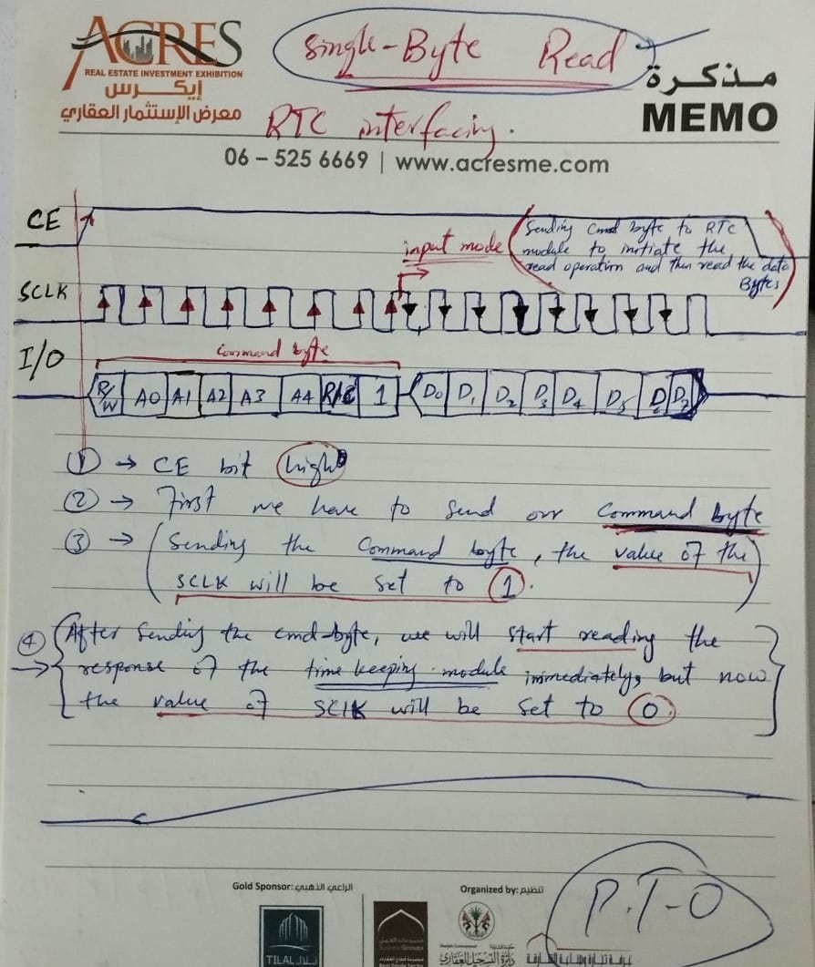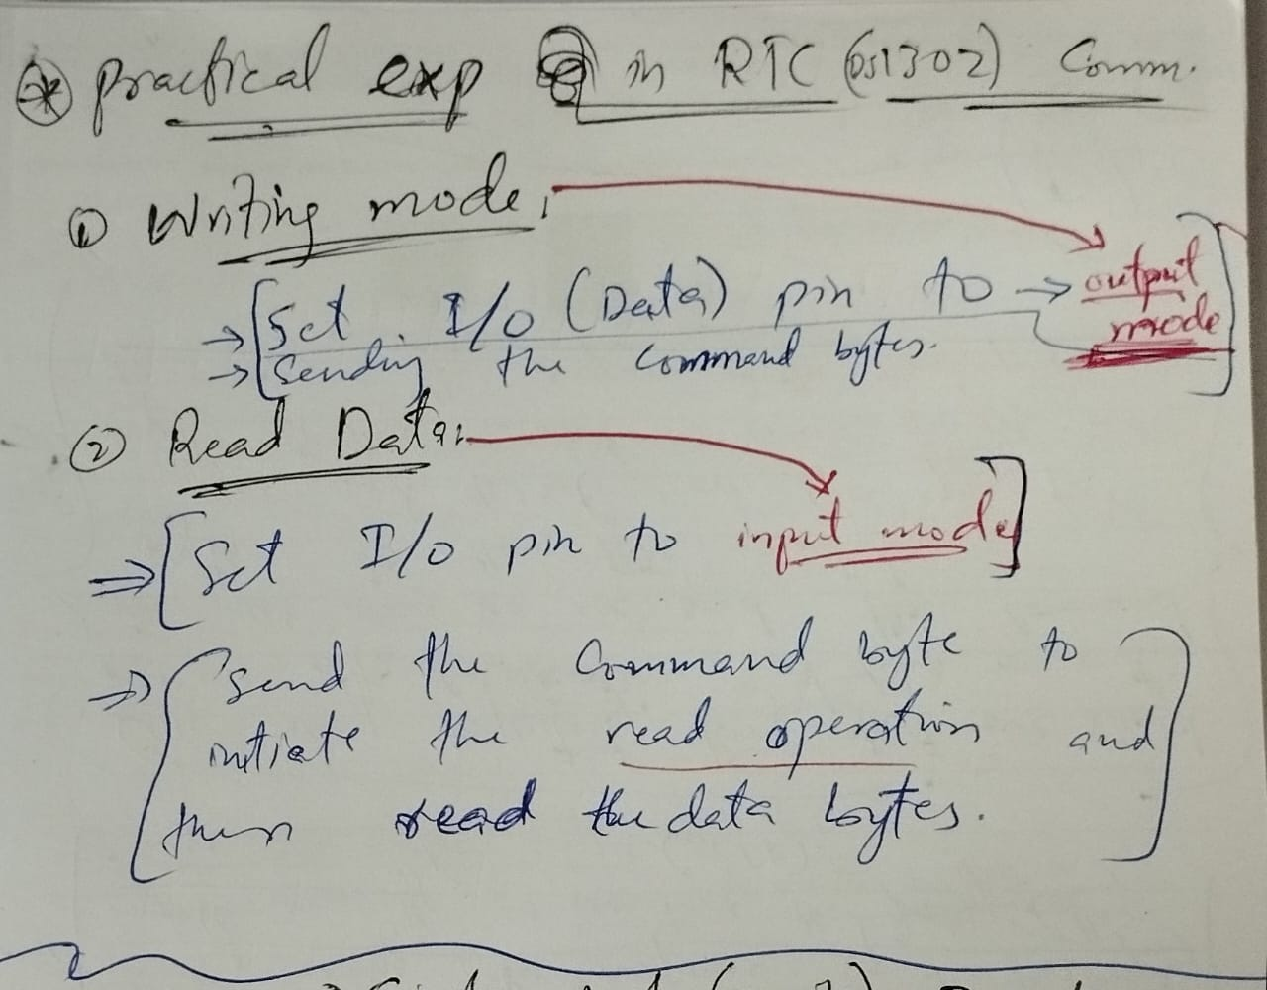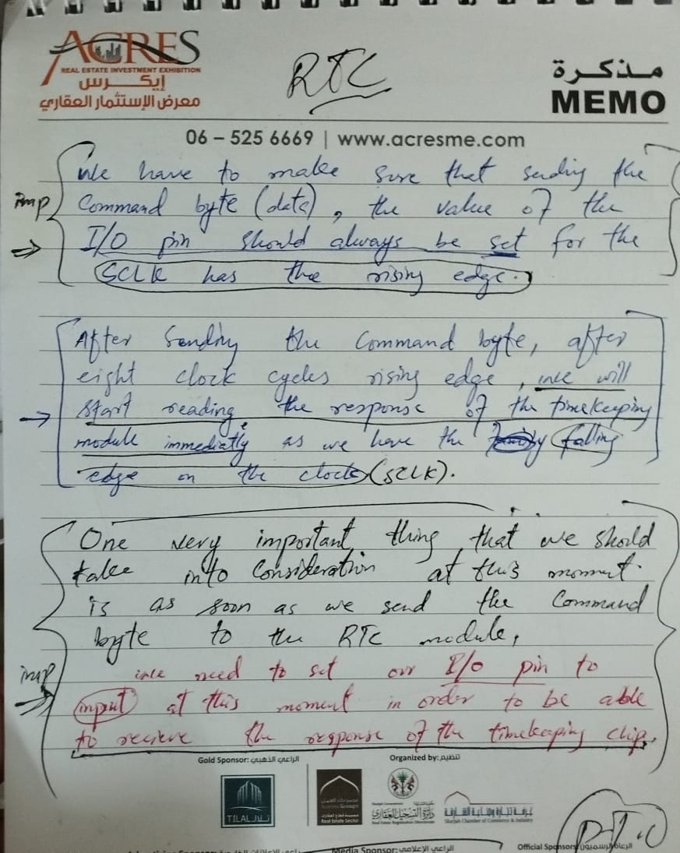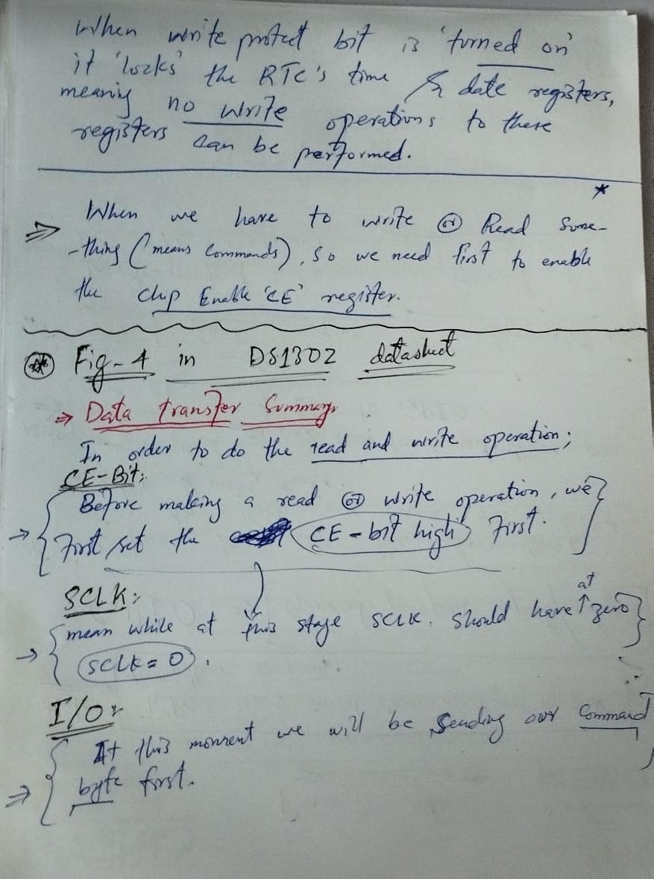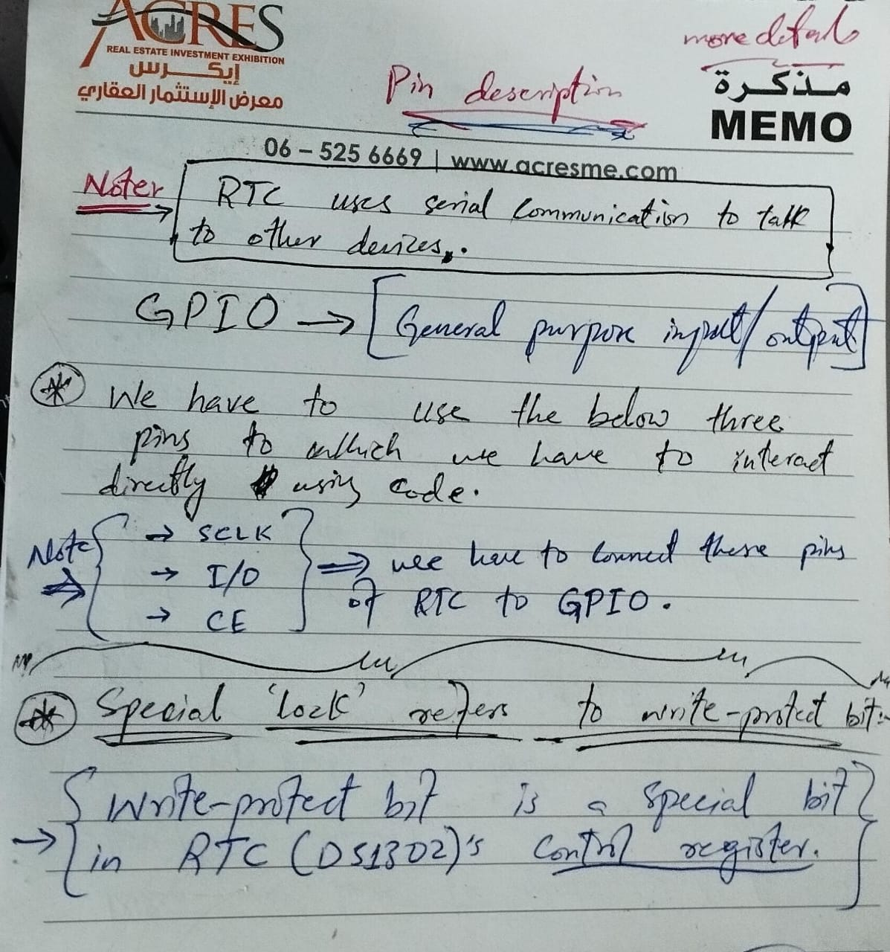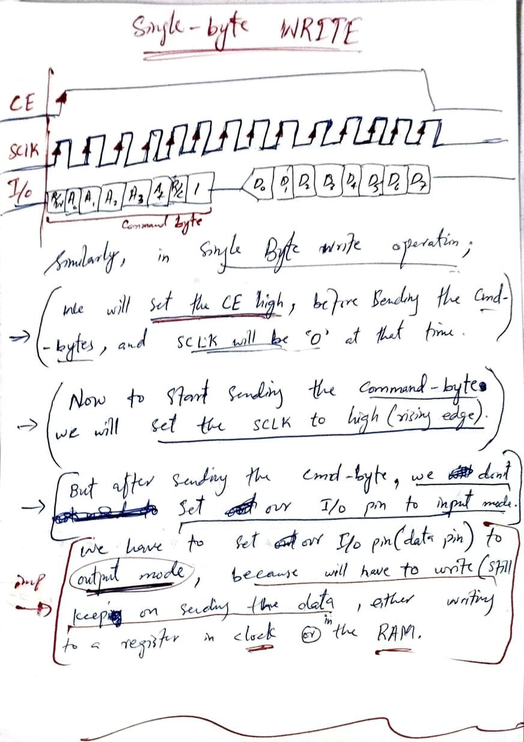

|  |
| --- |
|  |

The image you’ve provided shows a table from the DS1302 RTC (Real-Time Clock) datasheet, specifically detailing the **register addresses** and **definitions** for various time and control settings. Here’s a detailed breakdown of what each part of the table represents and how it works:

**Overview of the Table:**

* The table lists various registers in the RTC DS1302 that store information like seconds, minutes, hours, date, month, day, year, and control settings.
* Each register has a specific address for **reading** and **writing** operations.
* The registers are organized into bits (BIT 0 to BIT 7), where each bit can hold a value of either 0 or 1, representing part of the information stored in that register.

**Understanding Each Column:**

1. **READ/WRITE Address:**
   * **READ**: The address used to read data from a specific register.
   * **WRITE**: The address used to write data to a specific register.
   * For example, to read the seconds register, you use address 81h, and to write to the seconds register, you use address 80h.
2. **BITs (7 to 0):**
   * These columns represent the individual bits (BIT 7 to BIT 0) within each register. Each bit has a specific purpose, such as storing part of the seconds, minutes, hours, etc.
   * **CH (Clock Halt)**: Located at BIT 7 in the Seconds register. If this bit is set to 1, the clock stops (halts). If set to 0, the clock runs.
   * **12/24**: Located at BIT 6 in the Hours register. This bit determines whether the clock operates in 12-hour mode (1) or 24-hour mode (0).
   * **AM/PM**: Also in the Hours register (when in 12-hour mode), this bit (BIT 5) indicates AM (0) or PM (1) when in 12-hour mode.
3. **RANGE:**
   * The range column indicates the valid range of values that can be stored in each register.
   * For example, the seconds and minutes can range from 00 to 59, hours can range from 1–12 (in 12-hour mode) or 0–23 (in 24-hour mode), and so on.

**Detailed Explanation of Each Register:**

1. **Seconds (80h/81h):**
   * **CH (BIT 7):** Clock Halt. When set to 1, the clock stops. When set to 0, the clock is running.
   * **BIT 6 to BIT 4 (10 Seconds):** Stores the tens place of the seconds (0-5).
   * **BIT 3 to BIT 0 (Seconds):** Stores the unit place of the seconds (0-9).
   * **Range:** 00-59.
2. **Minutes (82h/83h):**
   * **BIT 6 to BIT 4 (10 Minutes):** Stores the tens place of the minutes (0-5).
   * **BIT 3 to BIT 0 (Minutes):** Stores the unit place of the minutes (0-9).
   * **Range:** 00-59.
3. **Hours (84h/85h):**
   * **BIT 7 (12/24):** Determines the hour format.
     + 0 for 24-hour format.
     + 1 for 12-hour format.
   * **BIT 5 (AM/PM):** Indicates AM/PM when in 12-hour mode & also stores the tens place of the hours.
     + 0 for AM.
     + 1 for PM.
   * **BIT 4 to BIT 0 (Hour):** Stores the hour value.
     + **Range:** 1-12 in 12-hour mode, 0-23 in 24-hour mode.
4. **Date (86h/87h):**
   * **BIT 5 to BIT 4 (10 Date):** Stores the tens place of the date.
   * **BIT 3 to BIT 0 (Date):** Stores the unit place of the date.
   * **Range:** 1-31.
5. **Month (88h/89h):**
   * **BIT 4 (10 Month):** Stores the tens place of the month (0 or 1).
   * **BIT 3 to BIT 0 (Month):** Stores the unit place of the month.
   * **Range:** 1-12.
6. **Day (8Ah/8Bh):**
   * **BIT 2 to BIT 0 (Day):** Stores the day of the week (1-7).
   * **Range:** 1-7.
7. **Year (8Ch/8Dh):**
   * **BIT 7 to BIT 4 (10 Year):** Stores the tens place of the year.
   * **BIT 3 to BIT 0 (Year):** Stores the unit place of the year.
   * **Range:** 00-99.
8. **Control Register (8Eh/8Fh):**
   * **BIT 7 (WP):** Write-Protect bit. When set to 1, it prevents any write operation to the clock and calendar registers.
   * **BIT 6 to BIT 0 (0):** Reserved or unused bits.
9. **Trickle Charger Register (90h/91h):**
   * **BIT 7 to BIT 4 (TCS):** Trickle Charge Select bits, which control the trickle charge feature of the DS1302.
   * **BIT 3 to BIT 2 (DS):** Diode Select bits for controlling the internal diodes used in the trickle charge circuit.
   * **BIT 1 to BIT 0 (RS):** Resistor Select bits for choosing the resistor value in the trickle charge circuit.
   * **Range:** Depends on the specific application.

**How It Works:**

* **Reading/Setting Time and Date:**
  + To **read** the time, you use the READ addresses (like 81h for seconds) to retrieve the values from the RTC registers.
  + To **set** the time, you write the appropriate values to the WRITE addresses (like 80h for seconds) after disabling the write protection by clearing the WP bit.
* **Control and Configuration:**
  + The control registers (like 8Eh/8Fh) are used to enable or disable features like the write protection (WP) or the trickle charge circuit.

**Summary:**

* Each register in the DS1302 has specific bits that control parts of the timekeeping and calendar functions.
* Understanding how to access and manipulate these bits allows you to control the RTC's behavior and retrieve accurate time and date information.

This table is essential for programming the DS1302 in your project, as it provides the necessary information to correctly configure and use the RTC's features.

|  |
| --- |
|  |

To utilize the information in the table for **interfacing the DS1302 RTC with the 8051 microcontroller**, you'll need to follow these steps:

**1. Setting the Time and Date:**

* **Select the Register:**
  + Determine which register you need to write to in order to set the time, date, or other parameters. For example, to set the seconds, you would use the write address 80h.
* **Format the Data:**
  + The time and date values need to be in Binary-Coded Decimal (BCD) format. For example, if you want to set the time to 12:34:56 PM in 12-hour format:
    - Hours register (12-hour mode): Write 84h to select the register and send 0x52 (where 5 indicates PM and 2 indicates 12).
    - Minutes register: Write 82h and send 0x34.
    - Seconds register: Write 80h and send 0x56.

**2. Reading the Time and Date:**

* **Select the Register:**
  + To read the current time, you would use the read addresses. For example, to read the minutes, you would use the address 83h.
* **Retrieve the Data:**
  + Send the read command and receive the data in BCD format. Convert this data back to binary to get the actual time or date.

**3. Using the Write Protection:**

* **Enable/Disable Write Protection:**
  + Write protection is controlled by the WP (Write Protect) bit in the register at address 8Eh.
  + To prevent accidental changes to the RTC, you can set this bit to 1. To allow changes, clear the bit (0).

**4. Clock Burst Mode:**

* **Efficiency in Communication:**
  + Use burst mode to read or write multiple registers in a single communication transaction. This is efficient if you need to update or read all time and date information simultaneously.
  + Example: To update all time and date values at once, use the write address BEh and send the data for seconds, minutes, hours, date, month, day, and year consecutively.

**5. Using the RAM:**

* **Store Custom Data:**
  + The RAM section provides 31 bytes of storage that you can use for any custom data. This data can be accessed similarly to how you access the time and date registers.
  + Example: Write to RAM by selecting the write address (C0h for the first byte) and sending your data. To read from RAM, use the corresponding read address (C1h for the first byte).

**6. Handling the Trickle-Charge Circuit:**

* **Battery Backup:**
  + The trickle-charge settings are controlled via the register at 90h. This is useful for maintaining timekeeping when the main power is lost, using a battery backup.
  + Adjust the TCS (Trickle Charge Select), DS (Diode Select), and RS (Resistor Select) bits to configure the trickle charge circuit.

**Implementation in Code:**

Here's a simplified example in C to set the time on the DS1302:

**c**

**Copy code**

void Set_Time_DS1302() {

// Assuming SPI communication

SPI_Write(0x80); // Write to seconds register

SPI_Write(0x56); // Set seconds to 56

SPI_Write(0x82); // Write to minutes register

SPI_Write(0x34); // Set minutes to 34

SPI_Write(0x84); // Write to hours register

SPI_Write(0x52); // Set hours to 12:00 PM (in 12-hour mode)

}

void SPI_Write(unsigned char data) {

// Function to send data to DS1302 via SPI

// Implementation will depend on your microcontroller's SPI library

}

**Key Points:**

* **Registers:** Use the correct register addresses for reading/writing time, date, and other settings.
* **Data Format:** Ensure data is in BCD format when writing to the DS1302.
* **Burst Mode:** Use burst mode for efficient communication when handling multiple registers.
* **RAM:** Utilize the RAM section for storing custom data.
* **Write Protection:** Set the WP bit to prevent accidental overwriting of time/date values.

This information allows you to program the 8051 microcontroller to interface with the DS1302 RTC effectively, enabling you to set, read, and manage time, date, and other functionalities in your embedded systems project.

**Binary-Coded Decimal (BCD)**

**Binary-Coded Decimal (BCD)** is a way of representing decimal numbers (like the digits 0-9) in binary form.

**How BCD Works:**

* In BCD, each digit of a decimal number is represented by its own 4-bit binary equivalent.
* For example:
  + The decimal number **5** is represented as 0101 in BCD.
  + The decimal number **9** is represented as 1001 in BCD.

**Example:**

* Let's take the decimal number **45**.
  + **4** is represented as 0100 in BCD.
  + **5** is represented as 0101 in BCD.
  + So, **45** in BCD is 0100 0101.

**Why BCD is Used:**

* BCD is used in systems where it’s important to keep the digits of a decimal number separate, like in digital clocks or calculators.
* It makes it easier to display numbers on devices that need to show each digit individually.

**Comparison to Binary:**

* Unlike pure binary, where the entire number is converted into binary (like 45 in binary is 101101), BCD handles each decimal digit separately, which can simplify certain types of processing.

**In Summary:**

BCD is a simple method to convert and handle decimal numbers in binary form by treating each digit independently, making it useful in digital systems where numerical display or processing is needed.

|  |
| --- |
|  |

The image you provided contains a table listing the register addresses and bit definitions for the RTC (Real-Time Clock) module, specifically showing how time and date information is stored. The blue writing on the image illustrates how binary values are converted into decimal and hexadecimal formats.

### ****Explanation of the Blue Writing in the above image:****

**Understanding the RTC Registers:**

The table shows how time and date information is stored in the RTC (Real-Time Clock) using specific registers. Each register holds a piece of information like seconds, minutes, hours, etc. The registers can be read from or written to using specific addresses.

**Key Components:**

* **READ/WRITE Columns:**
  + These show the address you use to read or write data to the RTC.
  + For example, 81h is the address to read the "Seconds" value, and 80h is the address to write the "Seconds" value.
* **BITS Columns (BIT 7 to BIT 0):**
  + Each bit in these columns represents a part of the value stored in the register. A bit is the smallest unit of data in a computer, represented as either 0 or 1.
* **RANGE Column:**
  + This tells you the possible range of values that can be stored in that register.
  + For example, seconds can range from 00 to 59.

**Explanation of the Blue Writing:**

1. **Seconds Register (Address 81h for reading, 80h for writing):**
   * The binary number 01010010 is written into the seconds register.
   * To understand this number:
     + The first four bits 0101 represent the digit 5.
     + The next four bits 0010 represent the digit 2.
   * To calculate the total seconds:
     + Multiply the first digit by 10 (because it's in the "tens" place): 5 * 10 = 50.
     + Add the second digit as it is in the "ones" place: 2 * 1 = 2.
     + So, 50 + 2 = 52 seconds.
   * This value 52 seconds is also represented as 0x52 in hexadecimal notation (which is just another way of writing numbers using base 16 instead of base 10).
2. **Minutes Register (Address 83h for reading, 82h for writing):**
   * The binary number 00110010 is stored in the minutes register.
   * To break it down:
     + The first four bits 0011 represent the digit 3.
     + The next four bits 0010 represent the digit 2.
   * To calculate the total minutes:
     + Multiply the first digit by 10: 3 * 10 = 30.
     + Add the second digit: 2 * 1 = 2.
     + So, 30 + 2 = 32 minutes.
   * This value 32 minutes is represented as 0x32 in hexadecimal.

**Why is This Important?**

* When you're programming a microcontroller to interact with the RTC, you need to know how to properly read from and write to these registers.
* For instance, if you want the RTC to keep track of 52 seconds, you need to write the value 0x52 to the seconds register.
* The understanding of binary and hexadecimal conversions helps you ensure that the correct time values are stored and retrieved from the RTC.

**In Summary:**

* Each register in the RTC stores a specific piece of time or date information in binary form.
* The blue writing in the image is explaining how these binary values translate into the actual seconds and minutes we use.
* Knowing how to interpret these values helps you accurately control and read the time on your RTC module.

|  |
| --- |
|  |

### ****Understanding the Address/Command Byte:****

In the image, the blue markings help explain how the command byte is structured when writing data to the RTC (Real-Time Clock) registers. Let's break it down:

#### **Command Byte Structure:**

* The command byte is an 8-bit value, which is used to select specific operations (like reading or writing to a register).
* Each bit in the command byte has a specific meaning, and they are numbered from 7 to 0, with Bit 7 being the most significant bit (MSB) and Bit 0 being the least significant bit (LSB).

#### **Bits Breakdown:**

* **Bit 7 (Value: 1):**
  + This bit is set to 1 in the command byte. It signifies that this is an instruction for the RTC.
* **Bit 6 (Value: 0):**
  + The value of this bit is 0, and it represents the "RAM/Clock" (CK) selection. Here, it's set to 0, which indicates that the operation is related to the clock registers, not the RAM.
* **Bits 5 to 1 (A4, A3, A2, A1, A0):**
  + These bits are used to select which specific register within the clock you're going to interact with.
  + The blue writing connects these bits, showing that they are all set to 0 in this example.
* **Bit 0 (Value: 0):**
  + This bit is used to select between read (RD) and write (WR) operations.
  + When this bit is 0, it indicates a write operation.

### ****Putting It All Together:****

* The blue writing explains that this specific command byte 10000000 is used to **write** (WR) data to the **seconds register** (0x80).

#### **Conversion and Meaning:**

* **Binary to Hexadecimal Conversion:**
  + The binary number 10000000 can be converted into hexadecimal:
    - The first half (1000) converts to 8.
    - The second half (0000) converts to 0.
  + So, the command byte in hexadecimal is 0x80.
* **Purpose of This Command:**
  + By sending this command byte 0x80 to the RTC, you're telling it to prepare to **write** data to the **seconds register**.

### ****Summary:****

* The command byte 0x80 (or 10000000 in binary) is specifically for **writing** to the **seconds register** in the RTC.
* The blue annotations in the image are highlighting how each bit in the command byte is set to achieve this specific operation.

This understanding is essential when programming the RTC, as you'll need to send the correct command byte before writing the actual time data to the respective registers.

|  |
| --- |
|  |

### Understanding the Data Transfer Summary with Blue Annotations:

The image shows a **Data Transfer Summary** for reading and writing a single byte to or from the RTC (Real-Time Clock). The blue and red annotations provide hints and help explain the operations in detail.

### ****Single-Byte Read Operation:****

#### **CE (Chip Enable):**

* The **CE** signal is used to enable the communication between the microcontroller and the RTC. It needs to be high (1) to start the communication.

#### **SCLK (Serial Clock):**

* The **SCLK** is the clock signal used to synchronize the data transfer. Each rising edge of SCLK allows one bit of data to be transferred.

#### **I/O Line:**

* The **I/O** line is used to transfer data between the microcontroller and the RTC.
* **Command Byte:** The first 8 bits that are transferred from the microcontroller to the RTC are known as the **command byte**. This byte contains information about the operation to be performed (read/write) and the address of the register to be accessed.

#### **Bits in the Command Byte (R/W, A0 to A4, R/C, 1):**

* **R/W:** This bit indicates whether the operation is a read (1) or write (0). In this case, it's a read (1).
* **A0 to A4:** These bits specify the address of the register in the RTC that you want to read from. The blue arrows show how each bit corresponds to a specific part of the address.
* **R/C (RAM/Clock):** This bit selects between accessing RAM or the clock. Here, it's set to 0, indicating a clock access.
* **1:** This bit is always set to 1 for read operations.

#### **Data Output:**

* After sending the command byte, the RTC will output the data from the specified register. In this case, the data is read out as 8 bits (D0 to D7).

### ****Single-Byte Write Operation:****

#### **CE and SCLK:**

* Just like in the read operation, the **CE** signal must be high, and the **SCLK** signal provides the clock pulses for synchronization.

#### **I/O Line:**

* The first 8 bits on the **I/O** line again represent the **command byte**, but this time it's followed by the **data byte** that you want to write to the RTC.

#### **Bits in the Command Byte:**

* **R/W:** This bit is set to 0 for a write operation.
* **A0 to A4:** These bits again specify the address of the register you want to write to.
* **R/C:** Set to 0, indicating access to the clock registers.
* **1:** This bit remains 1, but the overall operation is now a write.

#### **Data Input:**

* After the command byte, the next 8 bits are the data (D0 to D7) that you want to write to the specified register.

### ****Blue Annotations Explained:****

* **0x80:** The blue writing indicates that the command byte is 0x80 (hexadecimal), which is equivalent to the binary 10000000. This command byte is used to **write** data to the **seconds register** in the RTC.
* **Data Byte (0x32):**
  + The blue writing shows the data byte to be written as 0x32 in hexadecimal, which corresponds to 00110010 in binary.
  + In BCD (Binary-Coded Decimal), 0x32 represents 32, which in this case could be setting the seconds value to 32.
* **Breaking Down 0x32:**
  + **3:** The first nibble (0011) represents the tens digit 3.
  + **2:** The second nibble (0010) represents the units digit 2.
* **Note on Burst Mode:**
  + The note in the image mentions that in burst mode, the CE signal is kept high, and additional SCLK cycles are sent until the end of the burst. This is relevant when multiple bytes are being transferred in sequence.

### ****Summary:****

* The **read operation** fetches data from the RTC register specified by the command byte, while the **write operation** sends data to the RTC register specified by the command byte.
* The blue annotations explain how to construct the command byte for these operations, specifically focusing on writing 0x32 to the seconds register using 0x80 as the command byte. This sets the seconds value to 32 seconds in the RTC.

### Burst Mode Operation in RTC: A Detailed Explanation

To understand how burst mode works in a Real-Time Clock (RTC) for setting and reading the entire time and date, let’s break it down step by step. We’ll cover both the writing and reading processes, illustrating how data flows from start to finish.

### ****1. Setting Time and Date (Burst Write Mode):****

In the burst write mode, you’ll send the entire time and date information to the RTC in a single operation. Here’s how it works:

#### **Step 1: Initiate the Communication (Start Condition)**

* **Chip Enable (CE):** Set the **CE** pin high (1). This action tells the RTC that a communication session is starting.
* **Command Byte:** Send the command byte for burst write. For example, the command byte could be 0xBE. The 0xBE tells the RTC that you want to write the time and date starting from the seconds register.

#### **Step 2: Send Data Byte by Byte**

* **Clock Signal (SCLK):** Provide a clock signal via the **SCLK** pin. Each rising edge of this clock signal will allow the microcontroller to send one bit of data to the RTC.
* **Data Sequence:**
  + Send the seconds data first (e.g., 0x32 for 32 seconds).
  + Then, send the minutes data (e.g., 0x25 for 25 minutes).
  + Next, send the hours data (e.g., 0x10 for 10 AM/PM, depending on the format).
  + Followed by the day of the week (e.g., 0x03 for Tuesday).
  + Then, send the date (e.g., 0x15 for the 15th of the month).
  + After that, send the month (e.g., 0x08 for August).
  + Finally, send the year (e.g., 0x24 for 2024).

#### **Step 3: End the Communication (Stop Condition)**

* Once all bytes are transferred, pull the **CE** pin low (0). This action ends the burst write operation.
* The RTC now holds the complete time and date information in its registers.

### ****2. Reading Time and Date (Burst Read Mode):****

After setting the time and date, you might want to read this information back from the RTC. Burst read mode allows you to read all the registers in one go.

#### **Step 1: Initiate the Communication (Start Condition)**

* **CE (Chip Enable):** Set the **CE** pin high (1). This action tells the RTC that a communication session is starting.
* **Command Byte:** Send the command byte for burst read. For example, the command byte could be 0xBF. The 0xBF tells the RTC that you want to read the time and date starting from the seconds register.

#### **Step 2: Read Data Byte by Byte**

* **Clock Signal (SCLK):** Provide a clock signal via the **SCLK** pin. Each rising edge of this clock signal will allow the RTC to send one bit of data back to the microcontroller.
* **Data Sequence:**
  + The first byte received will be the seconds data (e.g., 0x32 for 32 seconds).
  + The next byte will be the minutes data (e.g., 0x25 for 25 minutes).
  + Then, the hours data (e.g., 0x10 for 10 AM/PM).
  + Followed by the day of the week (e.g., 0x03 for Tuesday).
  + Then, the date (e.g., 0x15 for the 15th of the month).
  + Next, the month (e.g., 0x08 for August).
  + Finally, the year (e.g., 0x24 for 2024).

#### **Step 3: End the Communication (Stop Condition)**

* Once all bytes are read, pull the **CE** pin low (0). This action ends the burst read operation.
* The microcontroller now holds the complete time and date information.

### ****Summary of the Process:****

* **Burst Write:**
  1. **CE High:** Start the communication.
  2. **Command Byte (0xBE)**: Initiate burst write mode.
  3. **Send Data:** Send each time/date byte in sequence.
  4. **CE Low:** End the communication.
* **Burst Read:**
  1. **CE High:** Start the communication.
  2. **Command Byte (0xBF)**: Initiate burst read mode.
  3. **Receive Data:** Read each time/date byte in sequence.
  4. **CE Low:** End the communication.

### ****Key Points to Remember:****

* **Efficiency:** Burst mode allows you to set or read the entire time and date with a single command, making the process faster and more efficient.
* **Sequential Operation:** In burst mode, data is transferred sequentially, starting from the seconds register and ending with the year register.
* **Command Byte:** The command byte determines whether you are reading or writing, and whether you are in burst mode or not.

By using burst mode, you can efficiently manage the time and date information in an RTC without the need for multiple command sequences, making it ideal for real-time applications where time synchronization is crucial.

### ****Overview Of DS1302 RTC And A Short Pseudo Code That How To Interface It:****

To help you understand the DS1302 and how to interface it with your 8051 microcontroller using I2C communication, I will break down the explanation into several sections:

### 1. ****Overview of DS1302 RTC****

The DS1302 is a real-time clock (RTC) integrated circuit that keeps track of time and date information. It operates on low power and can retain timekeeping data even when the main power supply is off, thanks to its backup battery capability. The DS1302 communicates with a microcontroller via a simple serial interface.

### 2. ****Key Features of the DS1302****

* **Clock/Calendar:** Provides seconds, minutes, hours, day, date, month, and year information, with an option for leap-year compensation.
* **31 x 8 RAM:** Provides 31 bytes of general-purpose RAM.
* **Binary-Coded Decimal (BCD):** Time and date values are stored in BCD format.
* **Operating Modes:** Supports both 12-hour and 24-hour clock modes.
* **Serial Interface:** Communicates with the microcontroller using a three-wire interface (SCLK, I/O, CE).
* **Trickle-Charge Capability:** Allows for charging an external capacitor for backup power.

### 3. ****Interfacing the DS1302 with the 8051 Microcontroller****

The DS1302 uses a three-wire serial interface, which includes:

* **SCLK (Serial Clock):** Clock input to synchronize data transfer.
* **I/O (Data Line):** Bi-directional data line for sending and receiving data.
* **CE (Chip Enable):** Used to initiate and terminate data transfers.

For interfacing with the 8051 microcontroller (STC 89C52RC), you would need to use bit-banging for the serial communication since the DS1302 doesn’t support standard I2C communication. The bit-banging method involves manually toggling the microcontroller’s GPIO pins to simulate the clock, data, and chip enable signals required for communication with the DS1302.

### 4. ****Pseudo Code for Interfacing DS1302 with 8051 Microcontroller****

Below is a detailed pseudo-code that outlines the steps to read time and date from the DS1302 and display it on an LCD connected to the 8051 microcontroller.

#### **Initialize Pins**

pseudo

Copy code

SET SCLK_PIN AS OUTPUT // Serial Clock Pin

SET IO_PIN AS INPUT/OUTPUT // Data Line Pin

SET CE_PIN AS OUTPUT // Chip Enable Pin

#### **Write Byte to DS1302**

pseudo

Copy code

FUNCTION Write_Byte(ByteData)

SET CE_PIN HIGH // Enable DS1302

FOR each bit in ByteData

SET SCLK_PIN LOW

IF BitData IS 1

SET IO_PIN HIGH

ELSE

SET IO_PIN LOW

END IF

SET SCLK_PIN HIGH

NEXT

SET CE_PIN LOW // Disable DS1302

END FUNCTION

#### **Read Byte from DS1302**

pseudo

Copy code

FUNCTION Read_Byte()

SET CE_PIN HIGH // Enable DS1302

ByteData = 0

FOR each bit

SET SCLK_PIN LOW

IF IO_PIN IS HIGH

SET ByteData BIT_HIGH

END IF

SET SCLK_PIN HIGH

NEXT

SET CE_PIN LOW // Disable DS1302

RETURN ByteData

END FUNCTION

#### **Initialize DS1302**

pseudo

Copy code

FUNCTION Initialize_DS1302()

Write_Byte(ControlRegister_Address, 0x00) // Disable Write Protection

Write_Byte(ClockBurst_Address, Initialize_Clock_Data) // Initialize Clock and Calendar

END FUNCTION

#### **Read Time from DS1302**

pseudo

Copy code

FUNCTION Read_Time()

Hour = Read_Byte(Hour_Address)

Minute = Read_Byte(Minute_Address)

Second = Read_Byte(Second_Address)

RETURN Hour, Minute, Second

END FUNCTION

#### **Read Date from DS1302**

pseudo

Copy code

FUNCTION Read_Date()

Day = Read_Byte(Day_Address)

Date = Read_Byte(Date_Address)

Month = Read_Byte(Month_Address)

Year = Read_Byte(Year_Address)

RETURN Day, Date, Month, Year

END FUNCTION

#### **Display Time and Date on LCD**

pseudo

Copy code

FUNCTION Display_Time_Date()

[Hour, Minute, Second] = Read_Time()

[Day, Date, Month, Year] = Read_Date()

DISPLAY Hour, Minute, Second ON LCD

DISPLAY Day, Date, Month, Year ON LCD

END FUNCTION

### 5. ****Steps to Implement****

1. **Initialize the DS1302** using the Initialize_DS1302() function.
2. **Write or Set Time/Date** if needed, using appropriate Write_Byte() calls.
3. **Read Time and Date** periodically using Read_Time() and Read_Date() functions.
4. **Display Time and Date** on the LCD using the Display_Time_Date() function.

### Conclusion

This pseudo-code gives you a structured approach to interface the DS1302 RTC with the 8051 microcontroller, focusing on serial communication using bit-banging techniques. You can now translate this pseudo-code into actual C code for your specific microcontroller platform.

# C51 MCU DS1302 clock module driver code:

<https://blog.csdn.net/Leo_William/article/details/104280963?spm=1001.2101.3001.6650.3&utm_medium=distribute.pc_relevant.none-task-blog-2%7Edefault%7EBlogCommendFromBaidu%7ERate-3-104280963-blog-81179103.235%5Ev43%5Epc_blog_bottom_relevance_base4&depth_1-utm_source=distribute.pc_relevant.none-task-blog-2%7Edefault%7EBlogCommendFromBaidu%7ERate-3-104280963-blog-81179103.235%5Ev43%5Epc_blog_bottom_relevance_base4&utm_relevant_index=6>

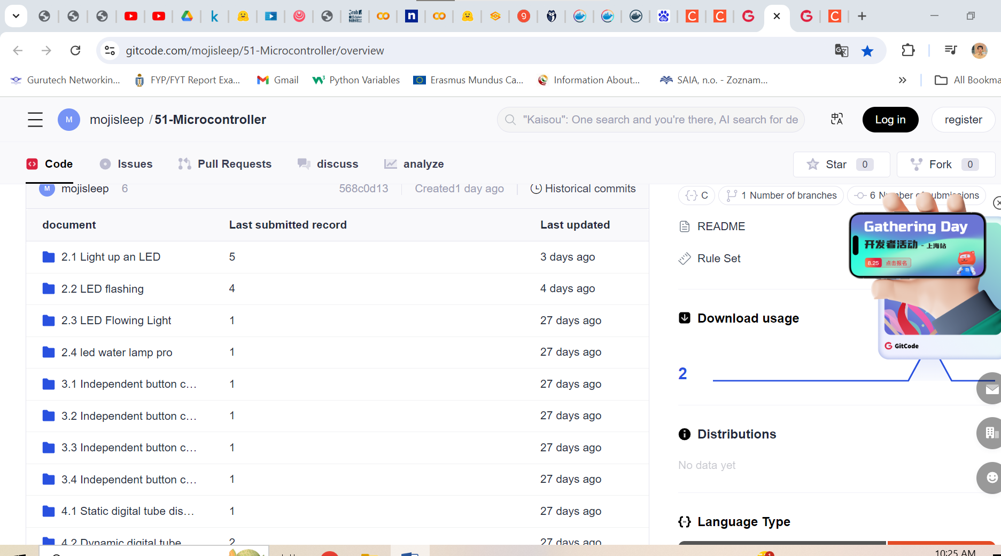 <https://gitcode.com/mojisleep/51-Microcontroller/overview>

<https://download.csdn.net/list/download/3-0-0-0-0-1.html?spm=1003.2021.3001.7881>



* 1. <https://blog.csdn.net/m0_74068921/article/details/131745259>